

CAPSTONE PROJECT REPORT
Report 6 – Software User Guides

– Hanoi, August 2026 –
Table of Contents
I. Record of Changes 3
II. Release Package & User Guides 4
1. Deliverable Package 4
2. Installation Guides 4
2.1 System Requirements 4
2.2 Installation Instruction 4
3. User Manual 4
3.1 Overview 4
3.2 Maternal Care Plan 6
3.2.1 Purpose of this Workflow: 6
3.2.2 Workflow Diagram: 6
3.2.3 Step-by-Step User Guide: 8
3.3 Baby Care Journey & Growth 14
3.3.1 Purpose of this Workflow: 14
3.3.2 Workflow Diagram: 15
3.3.3 Step-by-Step User Guide
Step 1: Create baby profile 16
3.4 Community Q&A & Moderation 20
3.4.1 Purpose of this Workflow: 20
3.4.2 Workflow Diagram: 21
3.4.3 Step-by-Step User Guide for Mother, family 21
3.4.4 Step-by-Step User Guide for Moderator 25
3.5 Verified Expert Network & Contribution 28
3.5.1 Purpose of this Workflow: 28
3.5.2 Workflow Diagram: 29
3.5.3 Step-by-Step User Guide on the Web: 30
3.5.4 Step-by-Step User Guide on the Mobile app: 34
3.6 AI Nurse Assistant & Risk Triage 42
3.6.1 Purpose of this Workflow: 42
3.6.2 Workflow Diagram: 43
3.6.3 Step-by-Step User Guide 44
3.7 Emergency Map Nearby Support 48
3.7.1 Purpose of this Workflow: 48
3.7.2 Workflow Diagram: 49
3.7.3 Step-by-Step User Guide 49

I. Record of Changes
Date | A*  M, D | In charge | Change Description
11/8/2026 | A | BachNQ | Add 1. Deliverable Package
11/8/2026 | A | BachNQ | Add 2. Installation Guides
11/8/2026 | A | HuyND | Add User manual
11/8/2026 | A | PhuongNT | Add User manual
18/9/2026 | M | PhuongNT | Synchronize Section 3 User Manual with Report 3 Section 1.2 Main Workflows (add 3.3 Expert Consultation with real UI screens, update 3.2, 3.4, 3.5, 3.6, 3.7)
*A - Added M - Modified D - Deleted

II. Release Package & User Guides

1. Deliverable Package
No. | Deliverable Item | Description
1 | Project Schedule/Tracking | Project Tracking - SEP490-G79-CareBridge
2 | Source Codes | https://gitlab.com/manhnc2/su26_sep490_g79
4 | Database Script(s) | 05_Development\Database\carebridge_full_schema.sql
5 | Final Report Document | Report7_Final Project Report
6 | Test Cases Document | Report5.0_Test Documentation
7 | Slide | https://canva.link/ksodtrge2vvbrfy

2. Installation Guides

2.1 System Requirements
● Mobile App: The mobile app requires an Android phone to run.
● Web (Operator): The web app requires a valid, up-to-date web browser for access.

2.2 Installation Instruction
● Mobile App: Download and install the APK file to gain access to the mobile application.
● Web (Operator): Access the web application by navigating to the designated URL using a supported web browser. Ensure that you have the necessary login credentials to proceed.

3. User Manual

3.1 Overview
CareBridge is a community-driven maternal and early childhood healthcare platform designed to support users throughout the care journey from preconception, pregnancy, and postpartum recovery to early childhood care. The platform provides personalized care support, reliable health information, health records, reminders, monitoring, expert support, and family cooperation.
CareBridge is developed as a digital platform that complements existing healthcare services rather than replacing healthcare professionals. Its objective is to improve continuity of care, access to trusted health information, personalized health management, and timely safety-oriented support for mothers, children, and families.
The core functionality of CareBridge is structured into six main workflows that guide users through key care stages, support interactions, and safety events:
1. Maternal Care Plan Workflow: Manages the personalized care journey across preconception, pregnancy, and postpartum stages; daily care plans; health metrics logging; physical safety monitoring; and emergency escalation.
2. Expert Consultation Workflow: Enables mothers to request teleconsultation with verified healthcare specialists, participate in real-time chat and audio/video consultations, and receive doctor-adjusted care plans with synchronized daily tasks.
3. Baby Care Journey & Growth Workflow: Tracks baby profiles, daily feeding/sleep/diaper logs, developmental milestones, WHO growth charts, and standard vaccination schedules.
4. Family Sync Workflow: Enables mothers to create family care groups, invite family members via direct notification or group code, approve join requests, and manage granular per-member sharing permissions.
5. Community Q&A & Moderation Workflow: Provides community question-and-answer exchanges with automated asynchronous AI safety screening, moderator review for flagged content, and user notification.
6. Verified Expert Network & Contribution Workflow: Governs expert identity and medical credential verification, professional profile and schedule management, and verified knowledge contributions to community Q&A.

The following functional groups support the main user needs throughout the care journey:

The following functional groups support the main user needs throughout the care journey:

The following functional groups support the main user needs throughout the care journey:
- Account, Trust & Access Control:
Manages accounts, roles, sessions, consent, notification preferences, and access to sensitive health information.
- Mother Care Journey:
Supports preconception, pregnancy, and postpartum care.
Manages health records, health indicators, pregnancy tracking, reminders, and care tasks.

3.2 Maternal Care Plan

3.2.1 Purpose of this Workflow:
This workflow guides mothers through personalized maternal healthcare from initial account setup and stage selection to day-to-day care tracking and risk evaluation. It provides structured health surveys, automated care plan generation, daily metric recording (blood pressure, blood glucose, fetal movement, symptoms), routine reminders, physical activity tracking, and intelligent health risk escalation.
Mothers use the CareBridge Mobile App to record daily indicators and receive proactive guidance. The system continuously evaluates logged indicators against clinical thresholds. When indicators are normal, routine care continues uninterrupted. When moderate anomalies arise, the user is guided to the AI Nurse Assistant for preliminary triage and doctor recommendation. When severe risks or fall impacts are detected, the system activates Medical Emergency Mode to protect maternal safety.

3.2.2 Workflow Diagram:

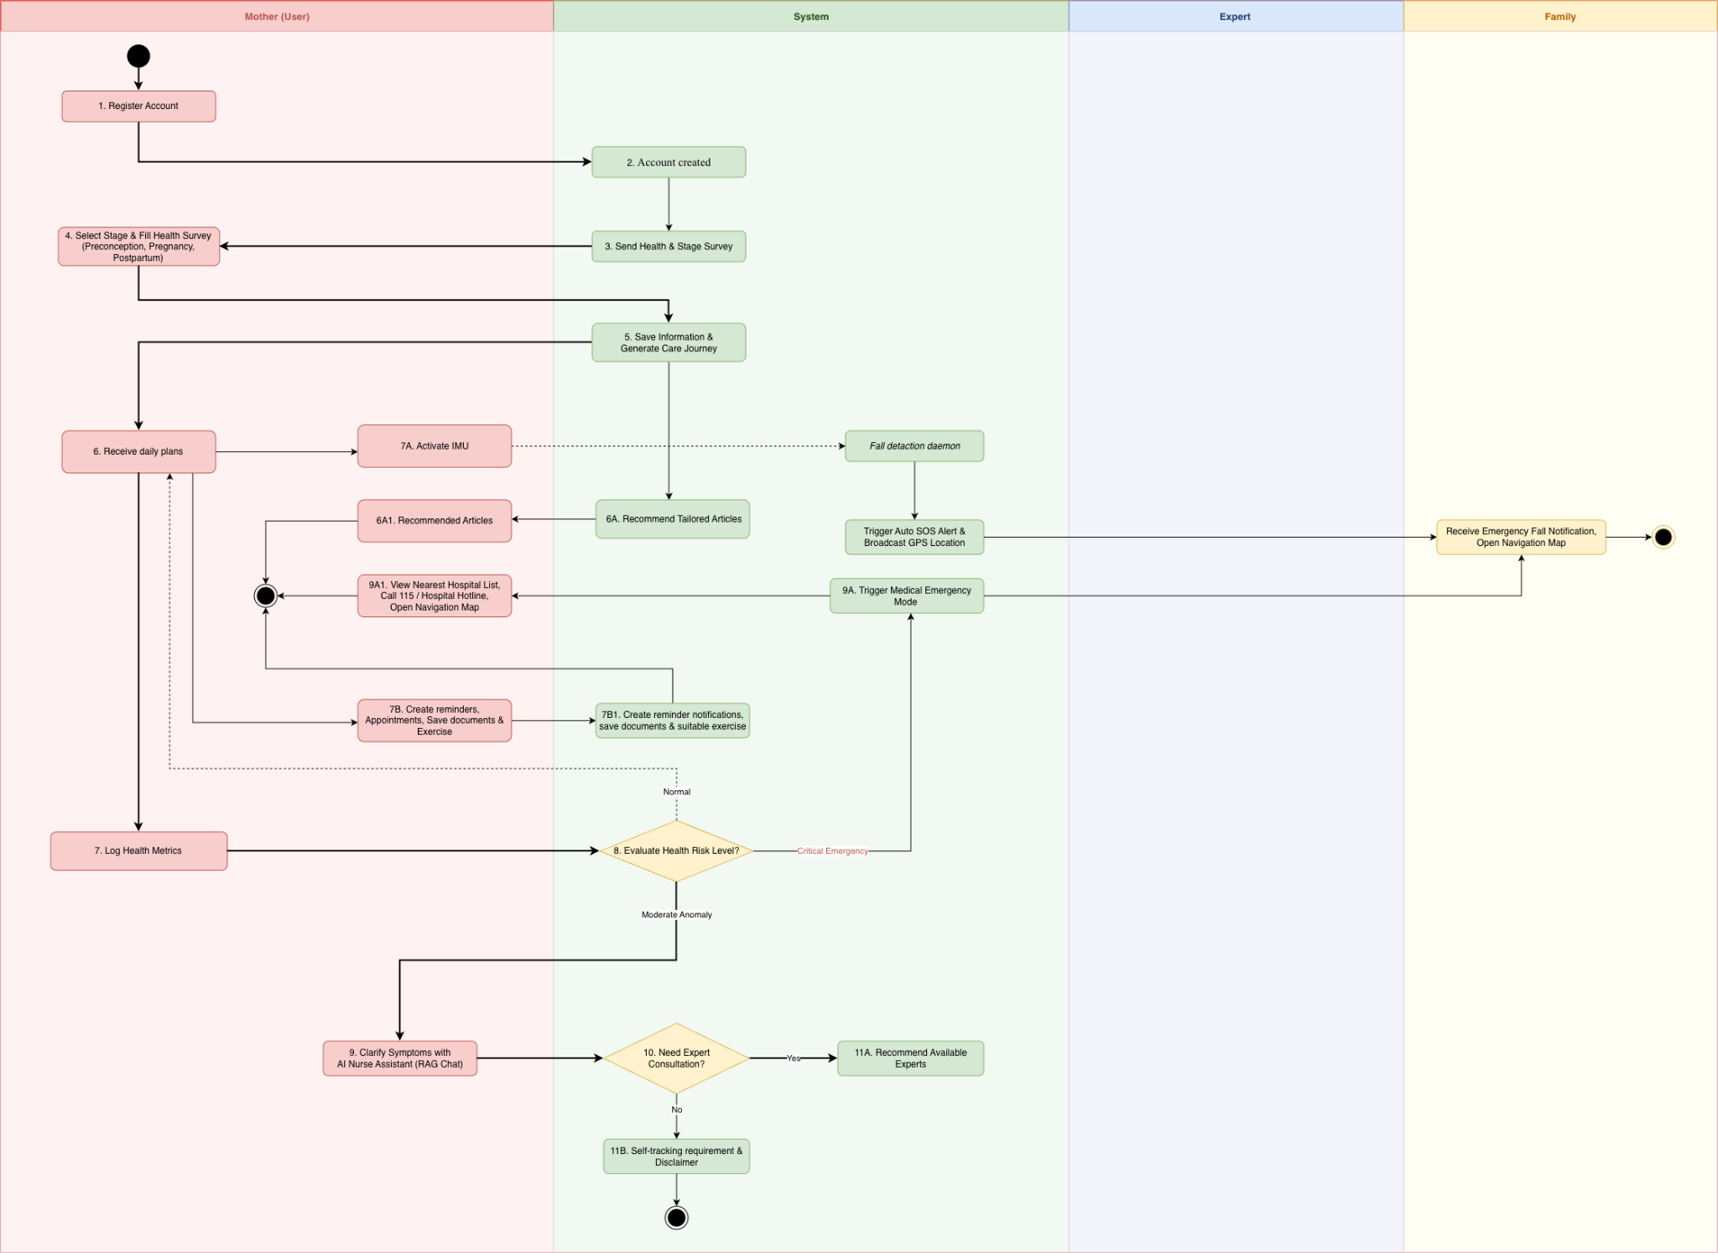
Figure 3: Maternal Care Plan Workflow
Image Detail: Maternal Care Plan Workflow (https://drive.google.com/file/d/12m_IDMHx_uKo_8aFVwf1scRTJx8T987D/view?usp=drive_link)

3.2.3 Step-by-Step User Guide:
Step 1: Register or Log in to the Account
Open the CareBridge mobile application.
If you already have an account, enter your registered email address and password, then select Log In. Alternatively, choose Continue with Google for quick sign-in.
If you are a new user, select Register, choose your account role (Mother, Family Member, or Doctor/Specialist), and fill in your profile details.
After successful authentication, the user lands on their dedicated dashboard.
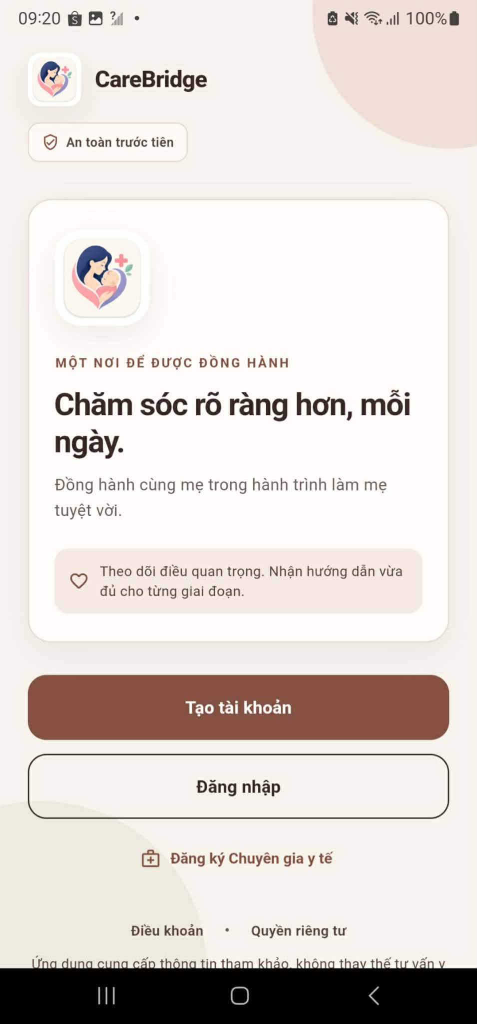
Step 2: Select the Maternal Stage
Upon initial setup or when entering a new phase of motherhood, navigate to the stage selector screen.
Select the stage that represents your current journey: Preconception, Pregnancy, or Postpartum.
For Pregnancy, enter your Last Menstrual Period (LMP) or expected Due Date (EDD) to determine gestational age.
For Postpartum, enter the baby's birth date and delivery method (vaginal or cesarean section).
The system uses this selection to provide personalized daily care plans and clinical milestones.
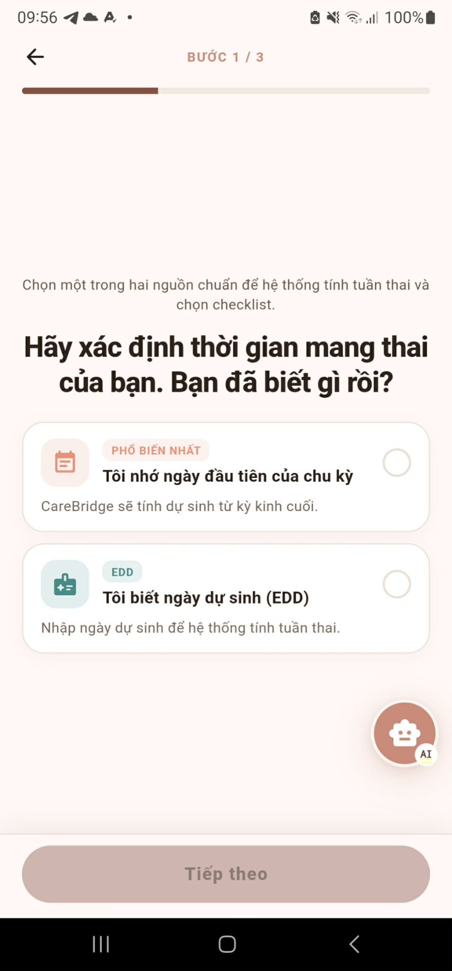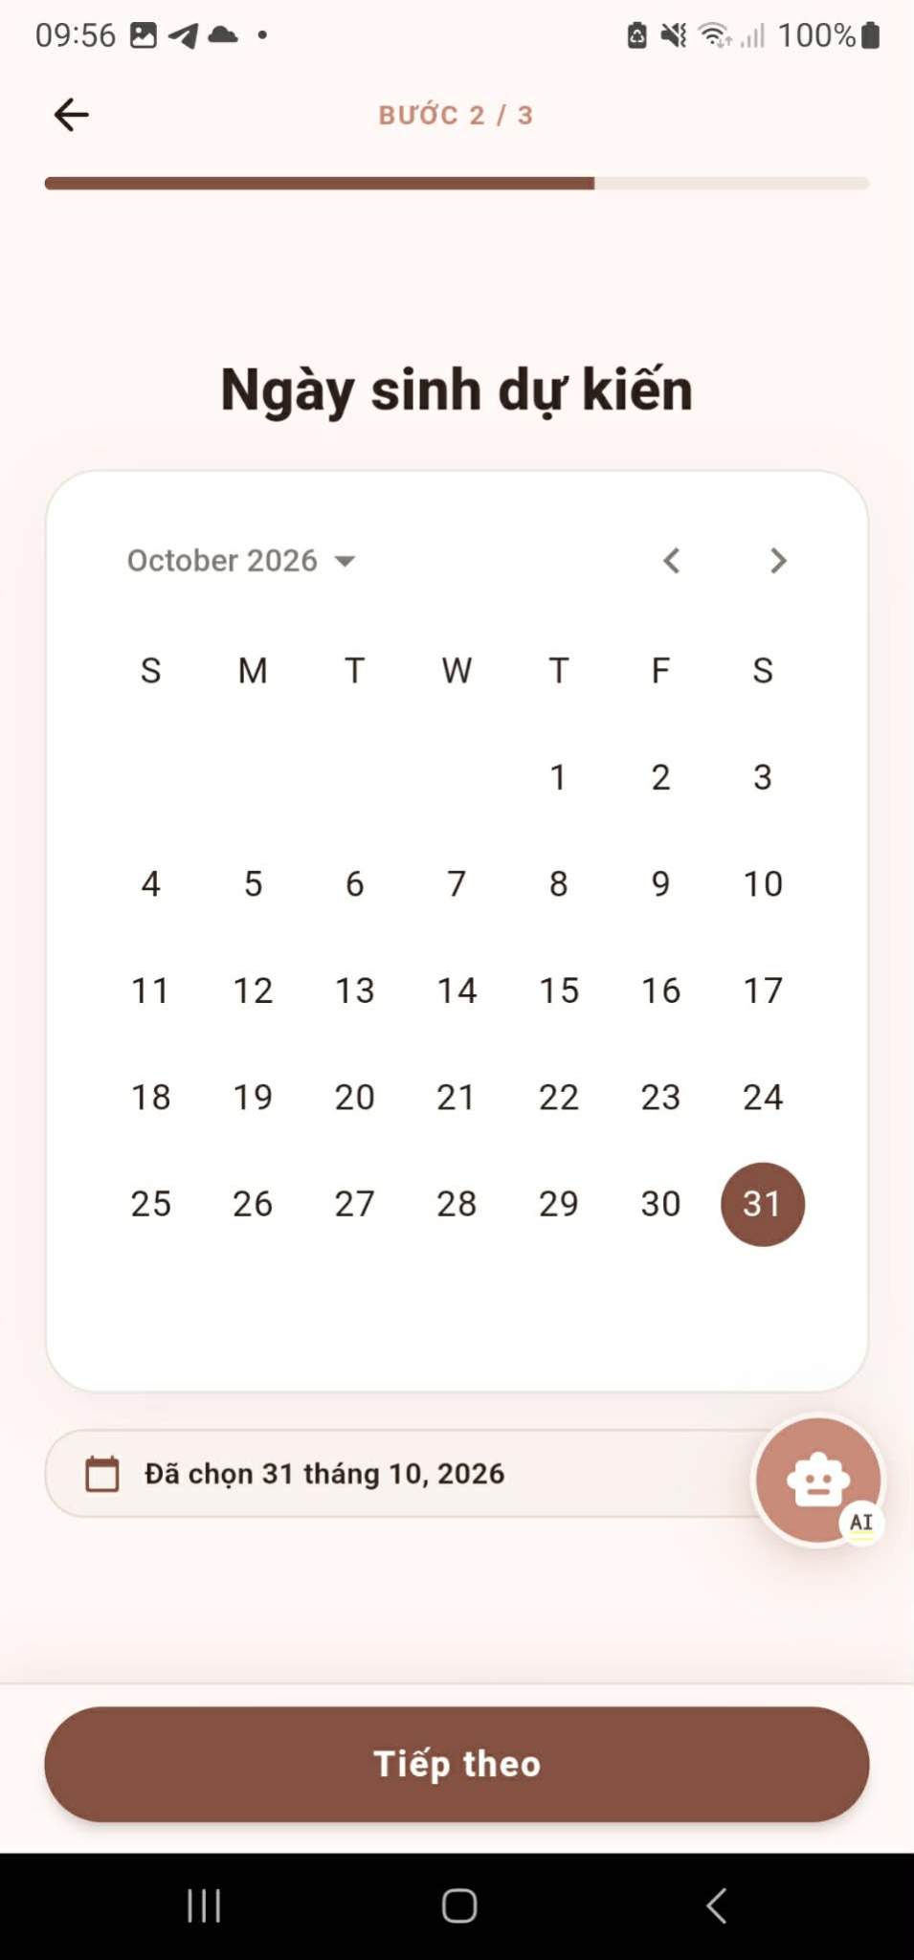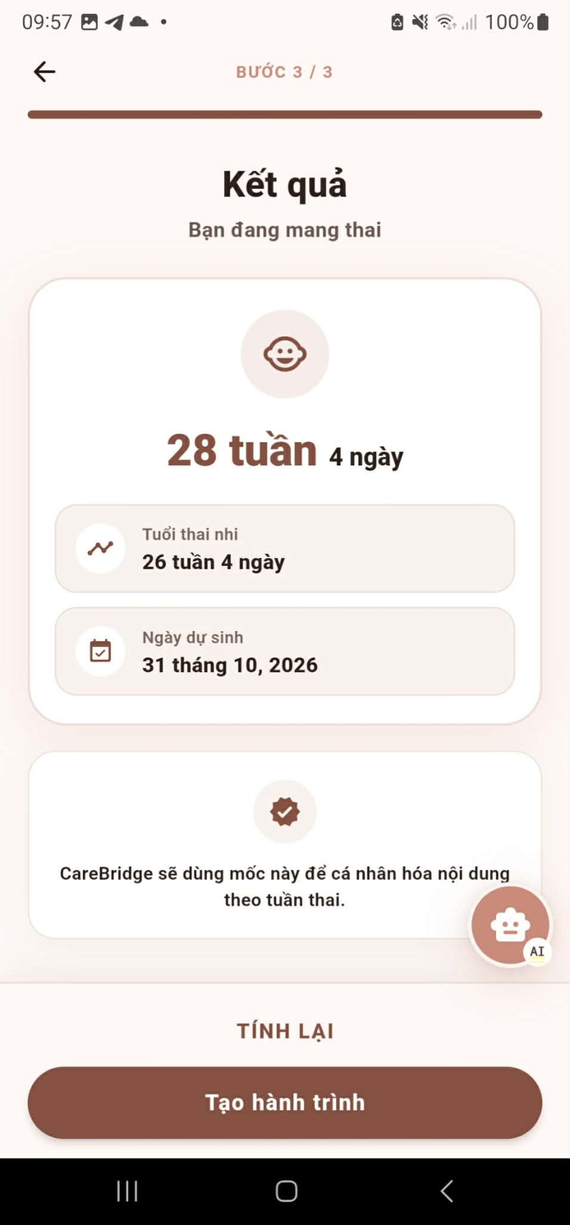
Step 3: Complete and Submit the Health Survey
Complete the onboarding health baseline survey.
Answer questions regarding pre-existing medical conditions (e.g., chronic hypertension, diabetes mellitus), obstetrical history, lifestyle factors, and physical health baselines.
Select Submit to finalize the survey.
The clinical rules engine analyzes the survey responses to calibrate your personalized care plan and establish baseline thresholds.
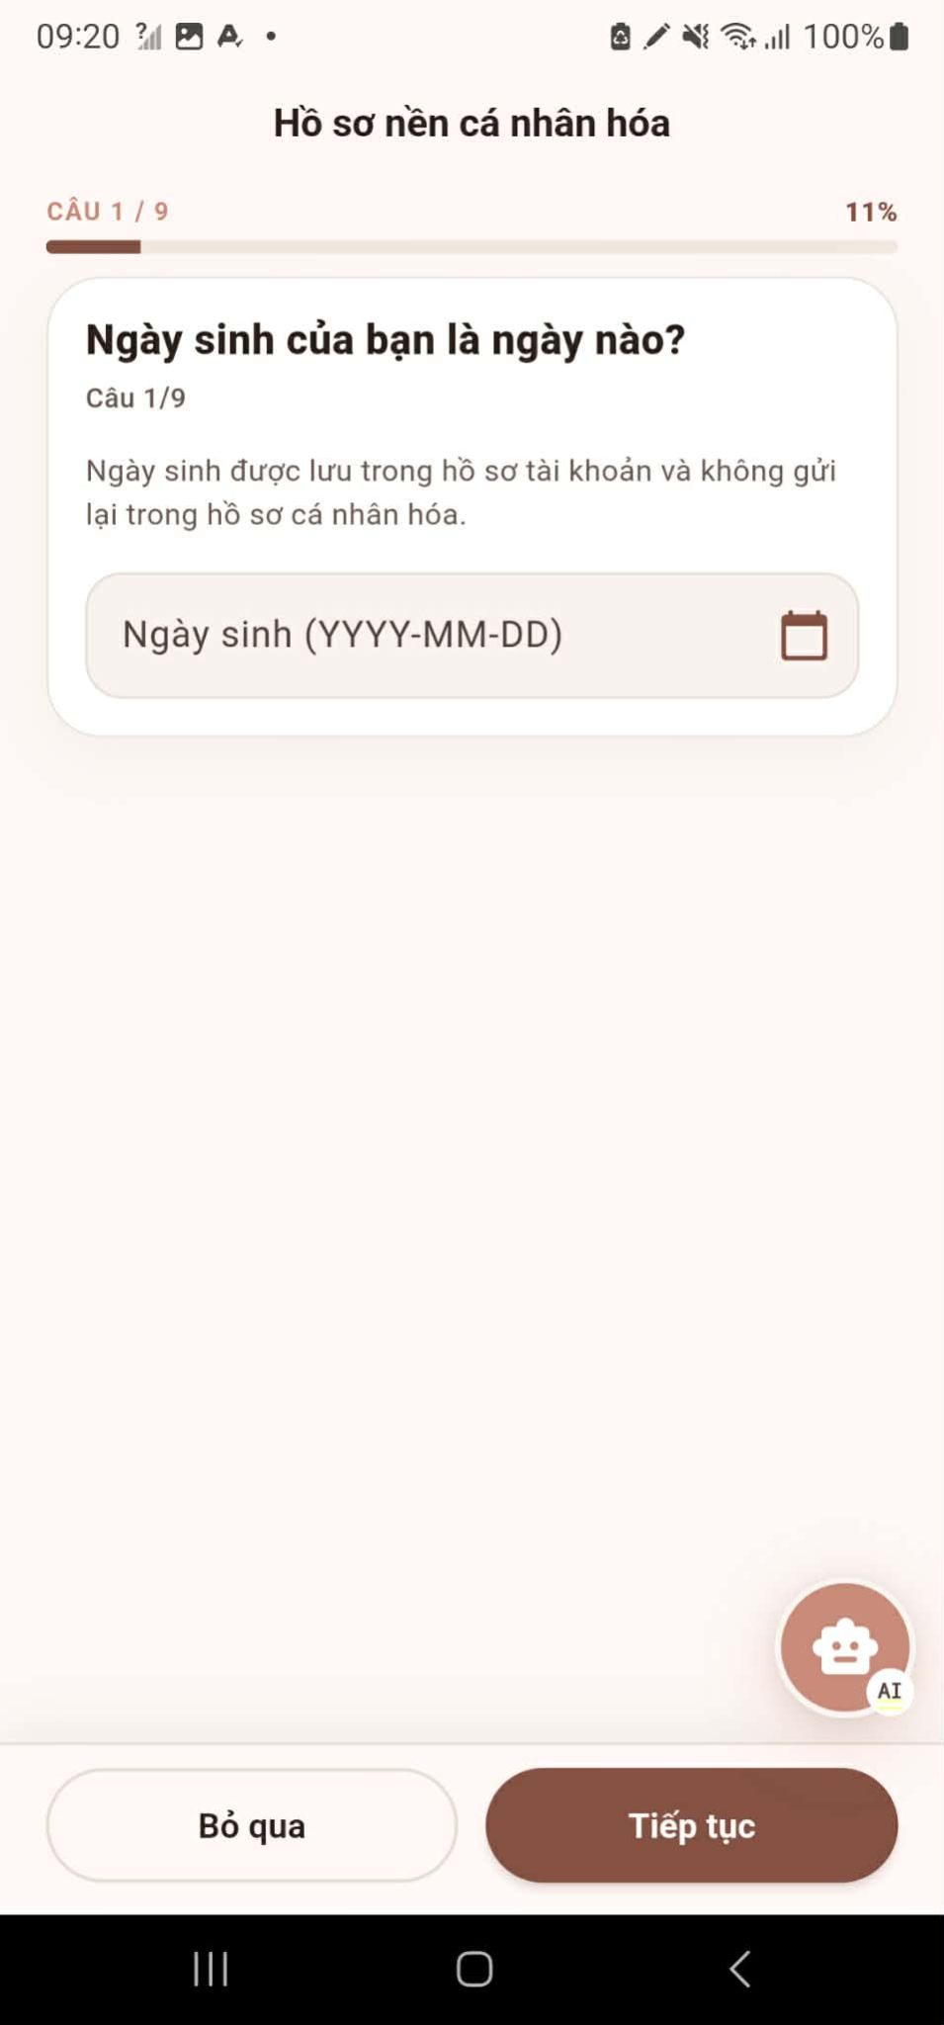
Step 4: Review the Generated Daily Care Plan
Review the personalized daily schedule generated for your specific trimester or recovery stage.
The plan outlines scheduled tasks: nutrition recommendations, hydration targets, medication reminders, prenatal exercise routines, and clinical vital checks.
Step 5: Track and Manage Daily Care
Record routine daily health metrics according to the daily plan (e.g., blood pressure, weight, blood glucose, symptoms, fetal kick counts).
Review upcoming reminders and schedule notifications, and adjust them when clinical timing or personal care needs change.
Open the pregnancy exercise section and follow stage-appropriate exercise regimens recommended for maternal wellness.
Read tailored, evidence-based educational articles curated by the system based on your current trimester and health profile.
Upload and securely archive clinical documents, lab results, and ultrasound records for upcoming healthcare visits.
Smart Activity Monitoring & Fall Safety: Enable smartphone IMU (Inertial Measurement Unit) sensor monitoring. A continuous background daemon analyzes accelerometer and gyroscope telemetry. Upon detecting a severe fall impact or emergency, the system automatically triggers an SOS alert and broadcasts real-time GPS location coordinates to family care group members.
Mark completed tasks so the system can record adherence and update your care progress.
Step 6: Health Risk Evaluation, AI Nurse Triage & Emergency Mode
The system monitoring engine continuously evaluates logged health indicators against clinical thresholds and personal baselines:
• Normal: When metrics are within safe boundaries, the user continues the routine daily care plan without interruption.
• Moderate Anomaly: When atypical indicators or non-urgent symptoms arise, open the AI Nurse Assistant (RAG Chat). Read the safety disclaimer (which emphasizes that AI triage provides non-diagnostic guidance and does not replace medical advice). Describe symptoms and answer interactive questions. If the assessment recommends specialist attention, the system suggests available verified doctors and transitions directly to Step 1 of the Expert Consultation Workflow (Section 3.3). If professional care is not required, self-tracking instructions and safety guidelines are provided.
• Critical Emergency: If severe anomalies, high-risk symptoms, or acute fall impacts are detected, the system immediately activates Medical Emergency Mode. Designated emergency contacts are notified, and the mother is presented with an urgent hospital dashboard: view a list of nearest hospitals, one-tap call 115 or hospital hotlines, and open turn-by-turn navigation map directions.

3.3 Expert Consultation

3.3.1 Purpose of this Workflow:
This workflow enables mothers to connect directly with verified healthcare specialists (obstetricians, pediatricians, nutritionists, lactation consultants) for professional teleconsultations. Mothers can browse expert profiles, view professional credentials and availability schedules, submit consultation requests with symptoms and medical questions, and track request status.
Assigned doctors review pending requests on the ExpertPortal or Mobile App, evaluate clinical urgency and triage context, and decide whether to accept or decline. Upon acceptance, a private direct conversation room is automatically provisioned for encrypted real-time chat, voice/video calling, and sharing vital health metrics, baby growth data, and pregnancy checklists. Following consultation, the doctor inspects shared records and prescribes customized care plan tasks with clinical guidance, which the system automatically synchronizes into the mother's daily schedule and reminder engine.

3.3.2 Workflow Diagram:

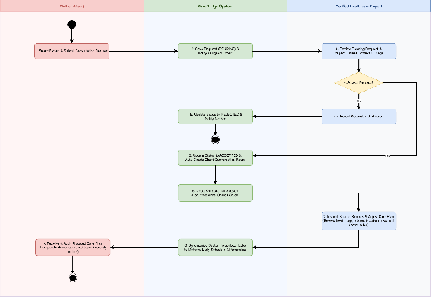
Figure 4: Expert Consultation Workflow
Image Detail: Expert Consultation Workflow (https://drive.google.com/file/d/12m_IDMHx_uKo_8aFVwf1scRTJx8T987D/view?usp=drive_link)

3.3.3 Step-by-Step User Guide for Mother (Mobile App):
Step 1: View Expert Profile and Select Consultation
Browse the verified healthcare specialist directory or tap on an expert recommendation card provided by AI Nurse Triage.
Open the 'Hồ sơ chuyên gia' (Expert Profile) screen to review detailed credentials:
• Doctor Name & Verification: Professional title and verified badge (e.g., BS Đỗ Hải Long, BS.CKII with verified badge).
• Contact & Qualifications: Official email (expert@carebridge.dev), phone number (+84902000001), patient ratings, and verified years of experience (15 năm kinh nghiệm).
• Lịch tư vấn sắp tới: Time slots published by the specialist ('Chọn ca phù hợp khi gửi yêu cầu tư vấn'). If none are pre-published, the system notifies 'Chuyên gia chưa công bố ca tư vấn sắp tới'.
• Thông tin công tác: Clinical specialties, hospital affiliations, and scope of practice.
Select the prominent 'Yêu cầu tư vấn' button to initiate a teleconsultation request.
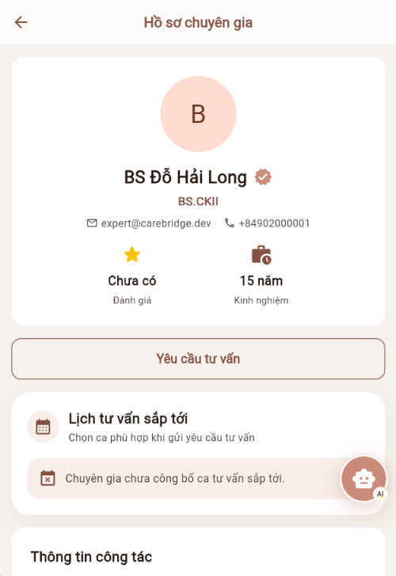

Step 2: Create and Submit Consultation Request
On the 'Tạo yêu cầu tư vấn' screen, complete the consultation request details:
• Assigned Specialist: Confirms selected doctor (e.g., 'Tư vấn cùng Chuyên gia BS Đỗ Hải Long').
• Chủ đề tư vấn: Enter a concise title summarizing your primary concern (up to 200 characters), e.g., 'Tư vấn kết quả siêu âm hình thái 22 tuần & cử động thai' or 'Tư vấn chế độ dinh dưỡng và xét nghiệm tiểu đường thai kỳ (OGTT)'.
• Mô tả chi tiết nhu cầu tư vấn: Describe your specific symptoms, gestational age, recent changes, questions, or medical history (up to 2000 characters).
• Chọn ca tư vấn: Choose a convenient consultation time slot from the expert's schedule (each slot lasts 1 hour). When the expert has no pre-scheduled slots, the card displays 'Chuyên gia chưa có ca rảnh sắp tới. Việc chọn ca hiện là tùy chọn.'
Select 'Gửi yêu cầu'. The system creates the consultation record with status 'Chờ phản hồi' (PENDING) and sends an immediate push notification to the specialist.
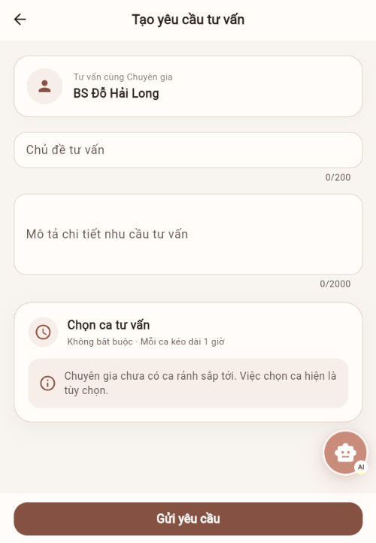

Step 3: Conduct Live Consultation (Chat, Clinical Data Sharing & Calling)
When the doctor accepts your request, open the consultation from notifications or the consultation list to access the 'Trò chuyện Trực tiếp' screen.
Real-Time Teleconsultation Features:
• Direct Messaging: Exchange encrypted real-time chat messages with the doctor.
• Voice & Video Calling: Select the Phone icon ('Gọi thoại') or Camera icon ('Gọi video') in the top navigation bar to start an interactive teleconsultation powered by ZegoCloud WebRTC.
• 'Đính kèm & Chia sẻ' (Attach & Share) Modal: Tap the (+) button to open the rich sharing sheet with exactly 7 clinical sharing options:
1. Chọn từ thư viện: Attach existing photos of ultrasound scans, lab reports, or prescriptions.
2. Chụp ảnh: Capture new medical photos using the smartphone camera.
3. Chọn tài liệu: Upload clinical documents in PDF, Word, or Excel format.
4. Chia sẻ chỉ số sức khỏe: Send structured vital data cards directly from your log (blood pressure, blood glucose, BMI, heart rate).
5. Chia sẻ phát triển của bé: Share the baby's growth curves and measurements (weight, length, head circumference).
6. Chia sẻ việc cần làm: Transmit current pregnancy care checklist progress and completed tasks.
7. Chia sẻ vị trí hiện tại: Send current GPS coordinates when emergency assistance or local clinic routing is required.
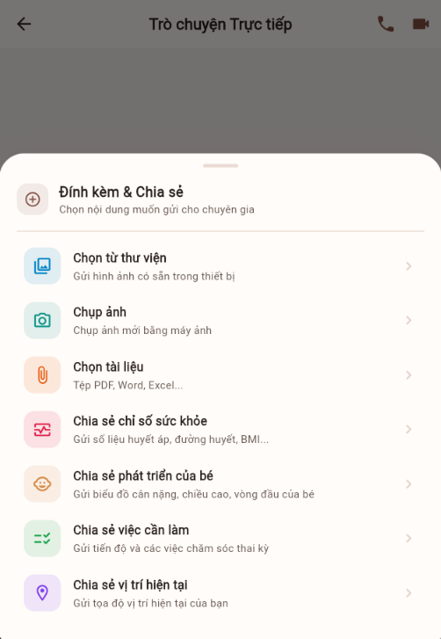

Step 4: Receive and Execute Updated Care Plan
Following the consultation, the doctor formulates clinical guidance and prescribes customized care tasks.
The system automatically validates and synchronizes doctor-prescribed tasks into your active daily care plan and reminder schedule.
The mother views updated clinical instructions directly on her daily home dashboard and completes them as part of her routine care journey.

3.3.4 Step-by-Step User Guide for Doctor / Expert:
Step 1: Review and Manage Consultation Requests (ExpertPortal)
Sign in to the ExpertPortal on the Web and select 'Yêu cầu tư vấn' from the left navigation menu.
The Consultation Requests dashboard allows specialists to manage incoming patient inquiries:
• Status Filter Tabs: Filter requests by status: 'Tất cả', 'Chờ phản hồi' (Pending), 'Đã chấp nhận' (Accepted), 'Đã từ chối' (Rejected), 'Đã hủy' (Canceled), or 'Đã hết hạn' (Expired).
• Search Bar: Quick lookup by patient name or consultation topic ('Tìm theo tên hoặc chủ đề...').
• Request List Table: Inspect sender name (e.g., Mẹ bầu 3), consultation topic, current status badge, submission time, and action buttons.
• Clinical Actions: For pending requests ('Chờ phản hồi'), select 'Chấp nhận' (Accept) to confirm the consultation or 'Từ chối' (Decline) with a clinical reason. For accepted requests, select 'Vào nhắn tin' to enter the live chat room.
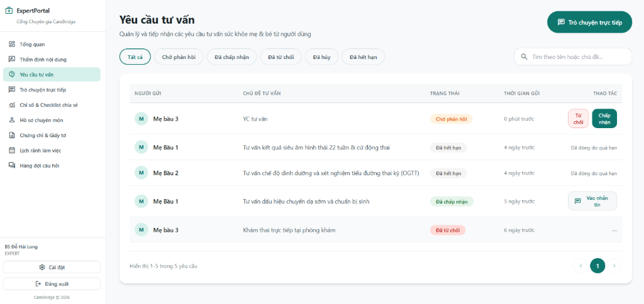

Step 2: Inspect Shared Maternal Records and Adjust Care Plan (ExpertPortal)
Select 'Chỉ số & Checklist chia sẻ' from the left navigation menu to monitor patient health data and adjust maternal care plans:
• Real-Time Monitoring Header: Displays real-time statistics including 'Mẹ bầu đang theo dõi' (total monitored mothers), 'Ca có cảnh báo / Bất thường' (abnormal cases), 'Tiến độ Checklist TB' (average checklist completion rate), and 'Live Sync' status.
• Case Cards: Each monitored mother has a dedicated case card showing gestational age (e.g., Tuần thai thứ 13, Tuần thai 24), latest update timestamp, and alert flags ('Cần lưu ý').
• Category Tabs: Switch between 'Chỉ số sức khỏe' (vital signs), 'Việc cần làm' (care checklist progress), and 'Phát triển bé' (fetal/baby growth).
• Prescribing Clinical Tasks: Select '+ Thêm việc' to prescribe new medical tasks, screening tests, dietary recommendations, or clinical reminders directly to the mother's care plan.
• Manage Existing Tasks: Edit (pencil icon) or delete (trash icon) existing tasks, view provenance tags (e.g., 'Gợi ý CareBridge'), and track status ('Chờ làm').
• Direct Chat Shortcut: Select 'Nhắn tin tư vấn' at the bottom of any patient card to immediately initiate or continue a direct teleconsultation with that mother.
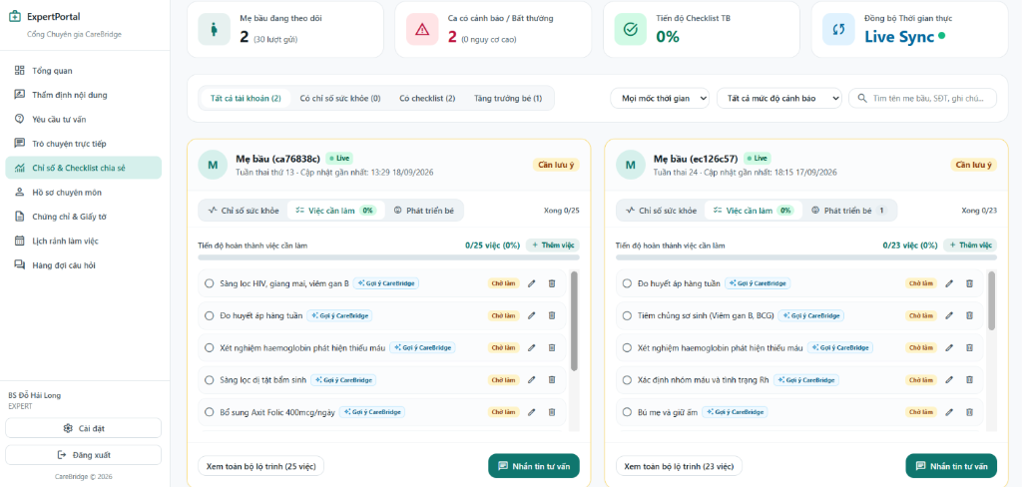

3.4 Baby Care Journey & Growth

3.4.1 Purpose of this Workflow:
This workflow helps mothers and caregivers create and manage baby profiles, receive age-appropriate baby-care guidance, record daily activities, monitor growth measurements and developmental milestones, and manage vaccination information. CareBridge stores the baby's journals, measurements, milestones, and vaccination records in a traceable timeline so that caregivers can review changes over time and prepare for healthcare appointments. Age- and stage-based reference labels are provided for observation and general guidance only. This workflow does not diagnose medical conditions, assess developmental disorders, or replace advice from a qualified pediatrician.

3.4.2 Workflow Diagram:
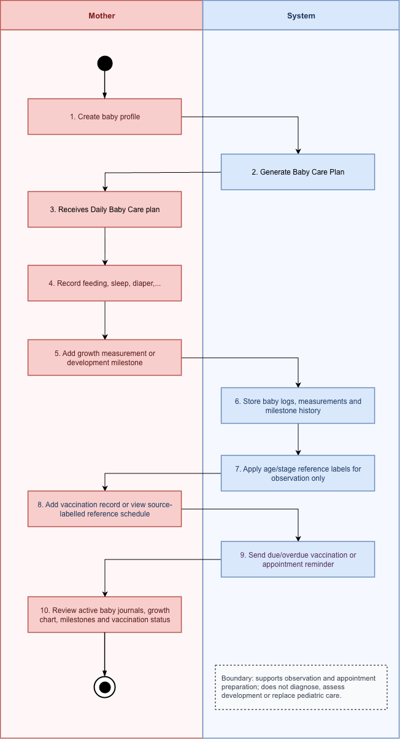
Figure 5: Baby Care & Growth Workflow
Image Detail: Baby Care & Growth Workflow (https://drive.google.com/file/d/1QSMfLg1bX08FhBtKyEOy4VsvTpXiaims/view?usp=drive_link)

3.4.3 Step-by-Step User Guide:
Step 1: Create baby profile
Open the CareBridge mobile application and select Hành trình - Bé.
Select Thêm hồ sơ bé.
Enter the baby's basic information, including nickname, date of birth, gender, birth weight, and birth length.
Add a profile photo if required.
Review the privacy notice. Baby information is protected and is used to calculate growth references and vaccination reminders.
Select Lưu hồ sơ.
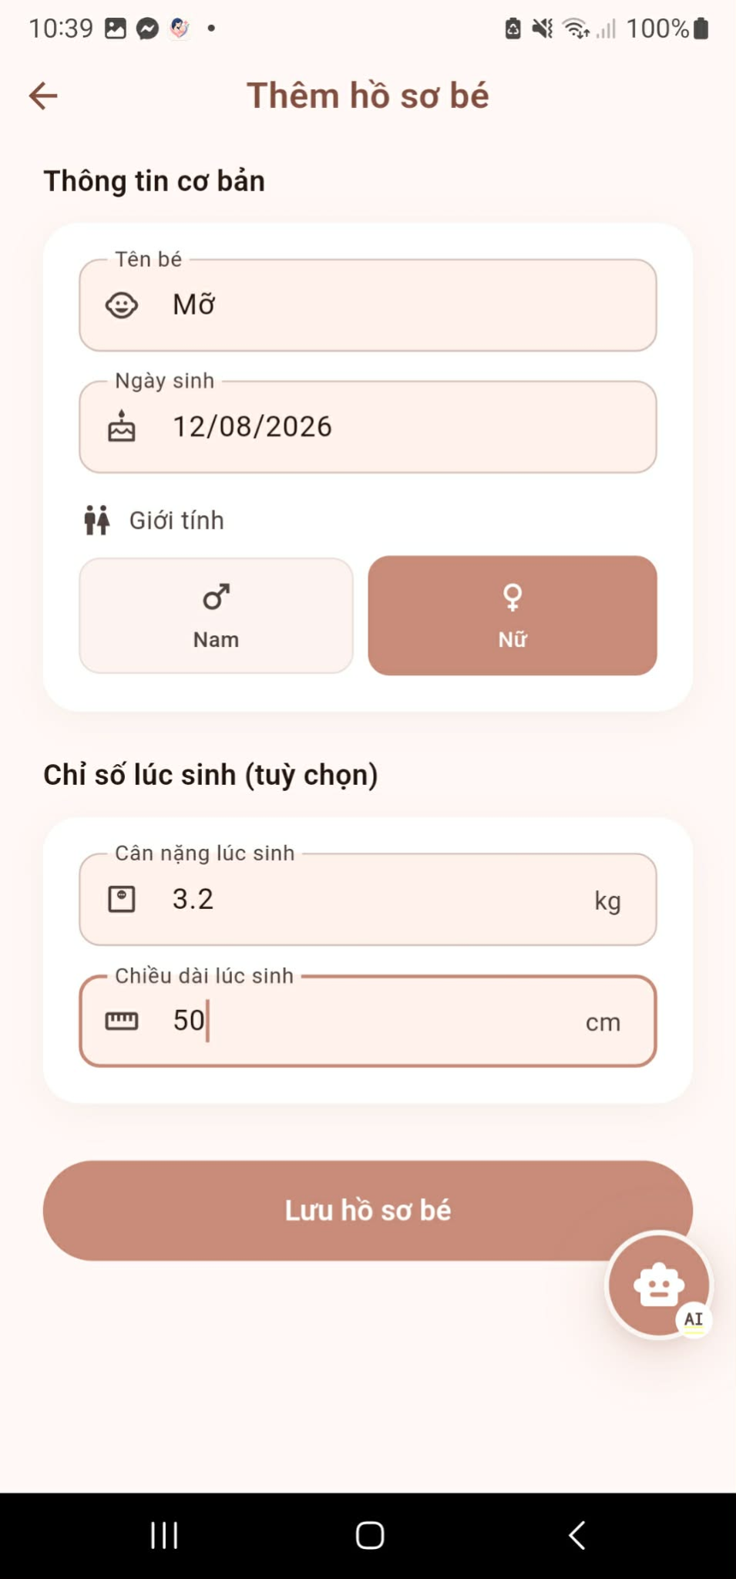
Step 2: Receives Daily Baby Care plan
After the baby profile is saved, CareBridge generates a daily baby-care plan based on the baby's age and available profile information.
Open the Trang chủ to view the recommended daily activities and reminders.
Review the plan and any available notifications, such as feeding, sleep, appointment, or vaccination reminders.
Use the plan as a tracking and preparation tool. The recommendations are general references and should not be treated as a medical diagnosis or treatment plan.
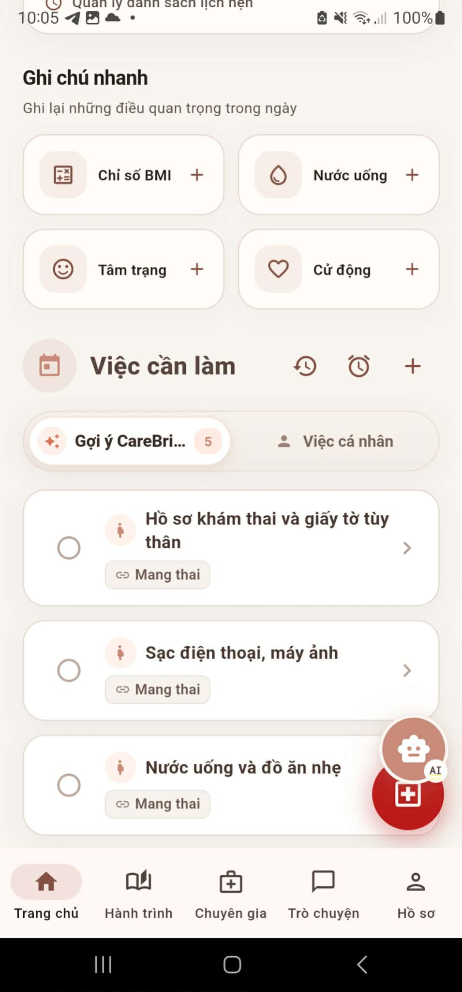
Step 3: Record feeding, sleep, diaper, symptom or night-mode journal
Open the active baby profile and select the relevant journal function.
Select the type of journal to record, such as Feeding, Sleep, Diaper, Symptoms, or Night Mode.
Enter the event details (e.g., feeding amount, sleep start/end time, symptoms, notes).
Step 4: Add growth measurement or development milestone
Select 'Chỉ số phát triển' to enter current weight, length, and head circumference.
Track developmental milestone achievements across motor, language, cognitive, and social domains.
Step 5: Add vaccination record or view source-labelled reference schedule
Open the active baby profile and select 'Tiêm chủng' (Vaccination).
Review the standard national vaccination schedule organized by developmental age milestones (at birth, 2 months, 3 months, 4 months, 6 months, 9 months, 12 months, 18 months).
View source-labelled reference information for each vaccine (target diseases, dosage, and recommended injection window).
Select 'Ghi nhận tiêm chủng' (Add Vaccination Record) to log administered vaccines, specifying injection date, vaccine batch, and healthcare facility.
The system stores the vaccination record and schedules automated push notifications for upcoming or overdue vaccination doses.
Step 6: Review active baby journals, growth chart, milestones and vaccination status
Open the baby care overview dashboard to inspect comprehensive health and growth progress.
Review the WHO Growth Chart (Biểu đồ tăng trưởng) comparing weight, height, and head circumference percentiles against international standard percentiles.
Check developmental milestone achievements across motor, language, cognitive, and socio-emotional domains.
Review the 24-hour daily log summary and upcoming vaccination checklist to prepare for pediatric checkups.

3.5 Family Sync

3.5.1 Purpose of this Workflow:
This workflow enables mothers to create a family care group, invite family members or secondary caregivers via direct notification or shared group code, and grant granular, per-member sharing permissions. Family members can view permitted maternal health metrics, calendars, care tasks, alerts, and shared medical records in read-only mode, fostering collaborative family care.

3.5.2 Workflow Diagram:
Figure 6: Family Sync Workflow
Image Detail: Family Sync Workflow (https://drive.google.com/file/d/1JHdrMOEvozkW9IhOc9RCJKFW2IdRPOp3/view?usp=drive_link)

3.5.3 Step-by-Step User Guide for Mother
Step 1: Care Group List Screen
Open the CareBridge mobile application, select Profile, then select Care Groups.
Review existing care groups. Each group shows its name, active status, and number of members.
Select Create Group, or Create First Group when no care group exists yet.
The system creates the care group, records the mother as OWNER, and links it to her active care journey.
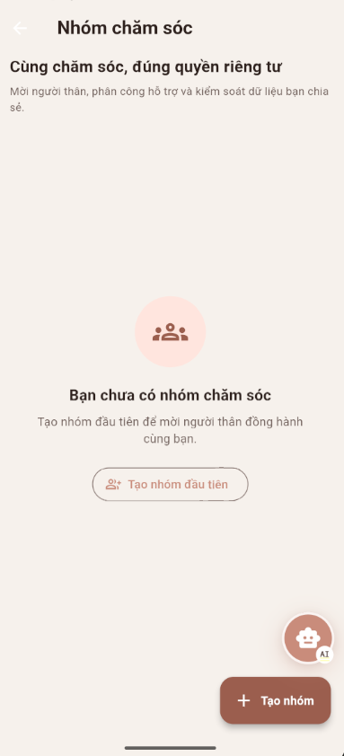
Step 2: Care Group Detail Screen
Select a care group from the list to open its detail screen.
View group information: group name, unique 6-character group code, status, and members.
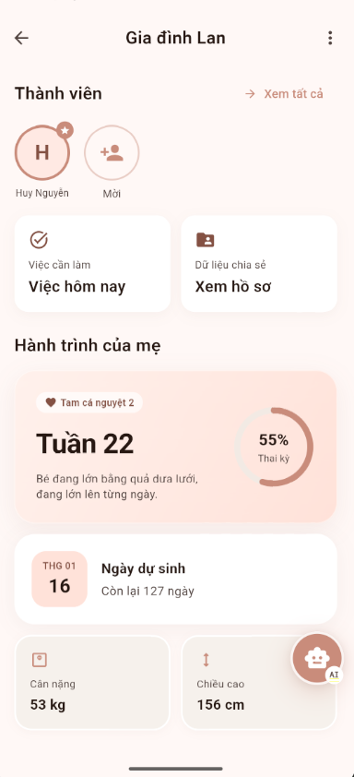
Step 3: Invite Family Member Screen
From the care group detail screen, select Invite Member.
Choose an invitation method: send direct invite via email/phone, or share the 6-character group code.
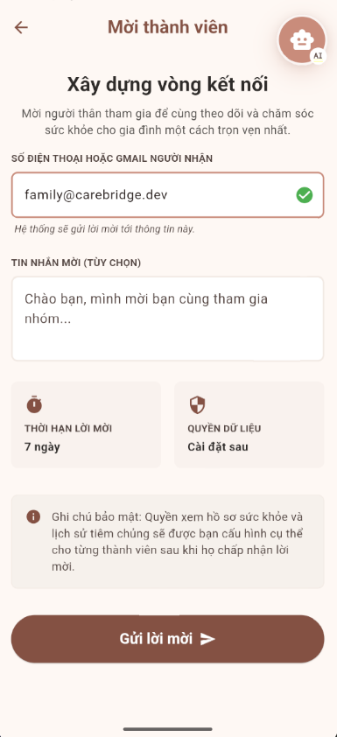
Step 4: Pending Invitations and Join Requests Screen
Open the pending requests screen to review member join requests.
Review applicant details: full name, relationship role, contact info, and request time.
Select Approve to accept the member or Decline to reject the request.
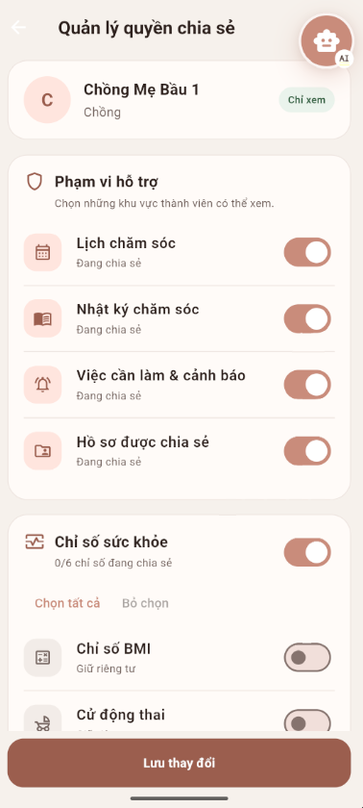
Step 5: Manage Sharing Permissions Screen
Select a confirmed member and choose Manage Permissions.
Configure granular toggle switches across Support Scope (calendar, care journal, tasks/alerts, shared records) and Health Metrics (BMI, fetal movement, blood pressure, hydration, EPDS, blood glucose, heart rate, temperature).
Select Save Permissions. The system updates data access controls immediately.

3.5.4 Step-by-Step User Guide for Family Member
Step 1: Join a Care Group (via Shared Code or Direct Invitation)
Open the CareBridge mobile application and navigate to 'Nhóm chăm sóc' (My Care Groups).
If receiving a direct phone/email invitation, open the pending notification, select your family relationship role (e.g., Chồng/Bố, Bà nội, Bà ngoại, Người chăm sóc, or Khác), and select Accept.
If joining with a group code, select 'Tham gia nhóm' (Join Group), enter the 6-character care group code provided by the mother, specify your family relationship role, and select Join Group.
The system records a join request and notifies the mother. The family member has no access to care data until the mother reviews and approves the request.
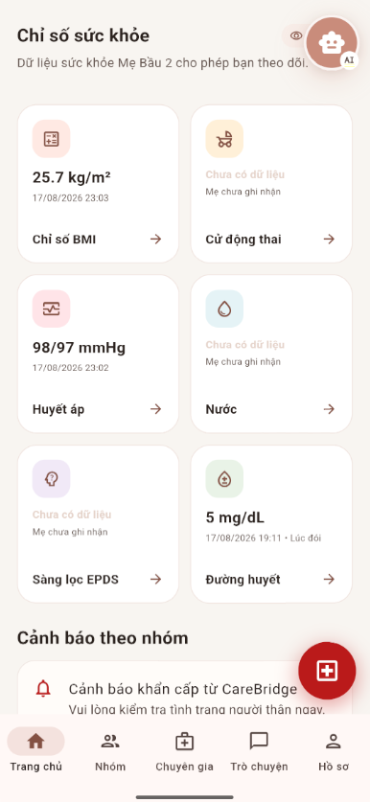
Step 2: Family Home and Shared Data Screens
After the mother approves access, open the care group to access shared views.
View permitted maternal metrics, shared calendar events, assigned tasks, and notifications in read-only mode.
Members can leave the group at any time by selecting Leave Group.

3.6 Community Q&A & Moderation

3.6.1 Purpose of this Workflow:
This workflow supports community knowledge sharing between mothers, family caregivers, and healthcare experts. Users browse categorized discussions, ask healthcare questions, and submit helpful answers. Automated asynchronous AI safety screening examines all submissions for prohibited content before public display, and human moderators review flagged items to maintain community safety.

3.6.2 Workflow Diagram:
Figure 7: Community Q&A & Moderation Workflow
Image Detail: Community Q&A & Moderation Workflow (https://drive.google.com/file/d/1YYkXs9BQgnGSMv7sHf2RZnzoPV879ynd/view?usp=drive_link)

3.6.3 Step-by-Step User Guide for Mother, family
Step 1: Community Feed Screen
Open the Community section from the main navigation bar.
Browse trending questions, filter by topic categories (Preconception, Trimester 1-3, Postpartum, Baby Care, Nutrition), or use the search bar.
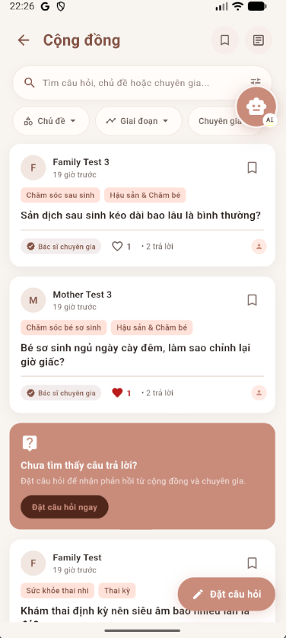
Step 2: Ask a Question Screen
Select the Floating Action Button (+) or Ask Question.
Enter a concise title, detailed description, and relevant topic category. Attach images if needed.
Asynchronous AI Safety Screening: Upon submission, the question is assigned status AI_PENDING. The system automatically screens the text and images for spam, harassment, and prohibited advertising. If no violations are detected, the question is marked APPROVED and published immediately. If potential violations are detected, the question is routed to the moderator queue (PENDING) and held until manual review.
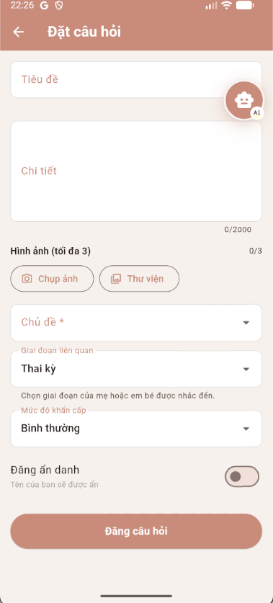
Step 3: Question Detail Screen
Select a question to view full details, verified expert answers, and community discussions.
Vote helpful or flag inappropriate content for moderation.

Step 4: Submit Answer Screen
Provide constructive answers or helpful tips to community questions.
Submitted answers also undergo asynchronous AI screening before becoming visible to the community. Authors receive push notifications regarding publication or moderation outcomes.
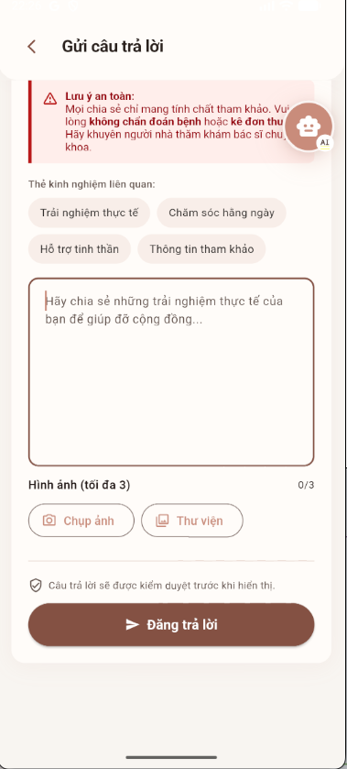

3.6.4 Step-by-Step User Guide for Moderator
Step 1: Pending Manual Review Screen
Sign in to the Moderator Portal and open the Pending Review queue.
Inspect flagged questions and answers with AI violation confidence scores.
Take moderation action: Approve (publish), Reject (delete with reason), or Lock discussion.

3.7 Verified Expert Network & Contribution

3.7.1 Purpose of this Workflow:
This workflow governs the verification, credential lifecycle, schedule management, and verified knowledge contributions of healthcare professionals. Experts submit identity documents and professional practice licenses for administrative verification. Upon approval, experts configure availability schedules and answer community questions within their approved medical scope, earning participation points and trust badges.

3.7.2 Workflow Diagram:
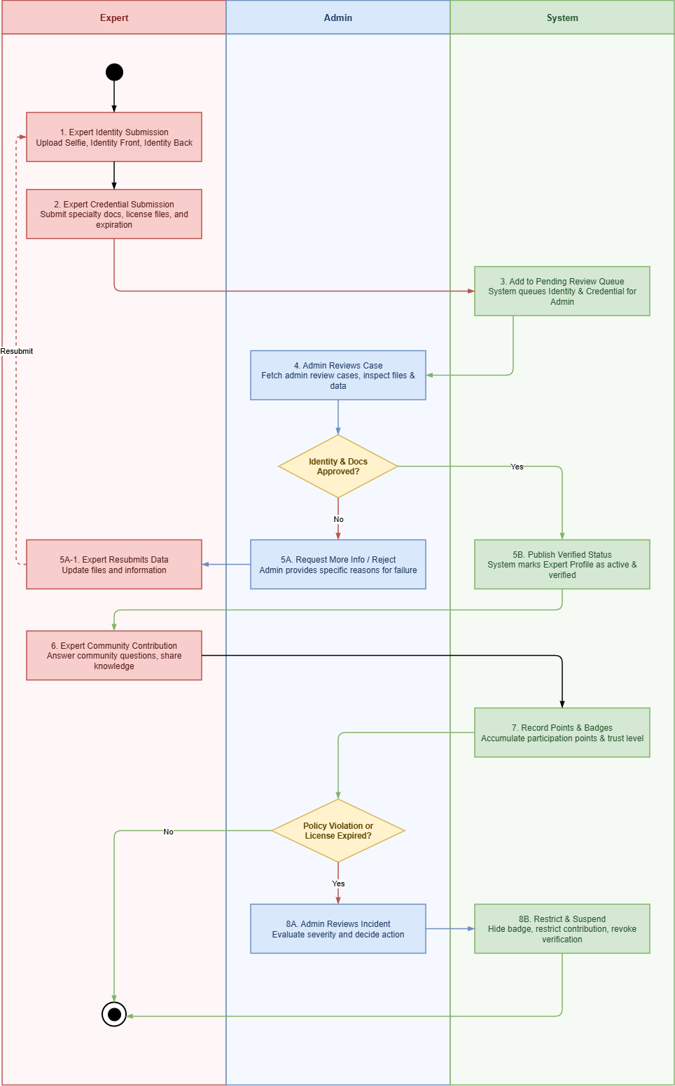
Figure 8: Verified Expert Network & Contribution Workflow
Image Detail: Verified Expert Network & Contribution Workflow (https://drive.google.com/file/d/16oIudra1rP--51sKMxwmWPkO6pkIO1LS/view?usp=drive_link)

3.7.3 Step-by-Step User Guide on the Web:
Step 1: Identity Verification Screen
Navigate to the Expert Registration portal and upload identity verification documents (selfie portrait, ID card front and back).
Step 2: Verification Completed Screen
Track administrative verification status. Upon document approval, the account receives the Verified Expert badge.
Step 3: Professional Profile Screen
Complete professional profile information: medical title (BS.CKI, BS.CKII, ThS, TS), hospital workplace, clinical specialties, and years of experience.
Step 4: Certificates & Documents Screen
Upload and manage medical practice certificates, specialty diplomas, and license issue/expiry dates.
Step 5: Working Schedule Screen
Configure weekly consultation availability calendar and define 1-hour teleconsultation slots.
Step 6: Community Question Queue Screen & Expert Contribution
Browse specialized community questions filtered by medical field. Answer questions to earn expert badges, community trust points, and public recognition.

3.7.4 Step-by-Step User Guide on the Mobile app:
Step 1: Expert Registration Screen
Sign up as a healthcare professional on the CareBridge Mobile App.
Step 2: Identity Verification Screen
Submit personal identification and practice credentials directly via mobile camera.
Step 3: Expert Dashboard Screen
Review personal practice metrics, upcoming consultation requests, and verified status badge.
Step 4: Community Screen & Knowledge Sharing
Contribute verified medical answers and health advice directly from mobile device.
Step 5: Working Schedule Screen
Manage teleconsultation booking slots on the go.
Policy Compliance & License Lifecycle:
The system actively tracks professional license expiration dates. When a license expires or when policy violations are confirmed by an administrator, enforcement actions are applied: verified badges are hidden, answering privileges restricted, or accounts suspended until updated credentials are submitted and approved.

